23.78: a) 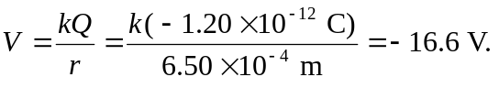
b) The volume doubles, so the radius increases by the cube root of two: 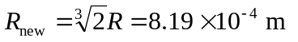 and the new charge is 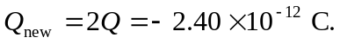 So the new potential is:
